37L09 General Arrangement – Side Profile
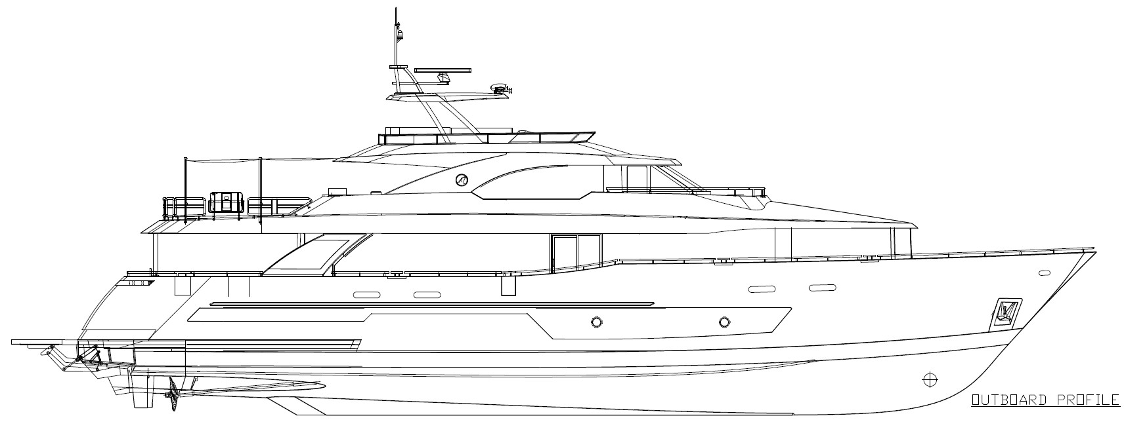
37L09 General Arrangement – Sun deck and Bridge deck
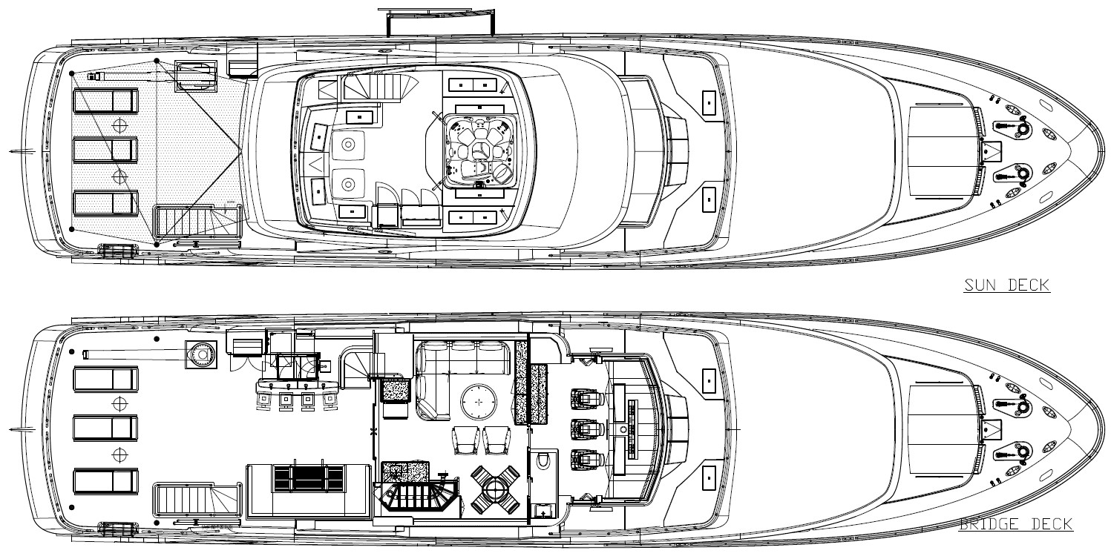

37L09 General Arrangement – Main and Lower Decks
